Borja, Ellen Mae J.
BSIT-3C
Activity 2
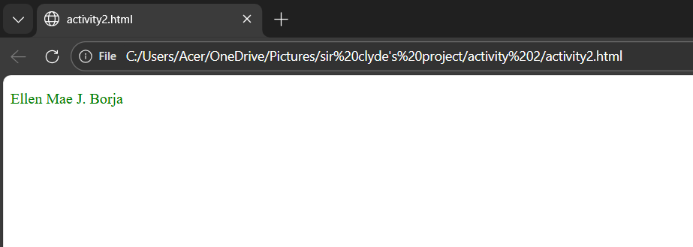
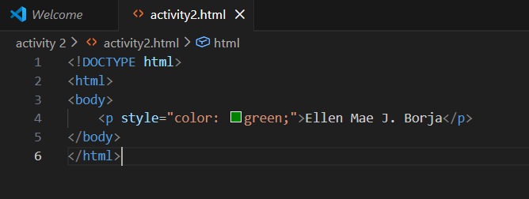
Exercise 1: print your name in green.

Exercise 2: Print the numbers 1-10, each number being a different color.
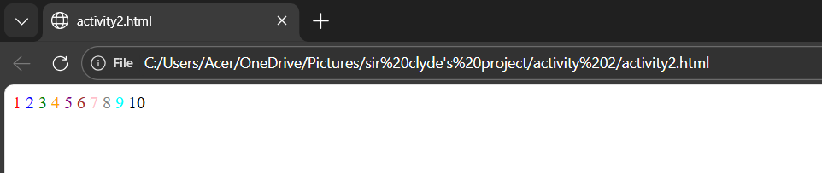
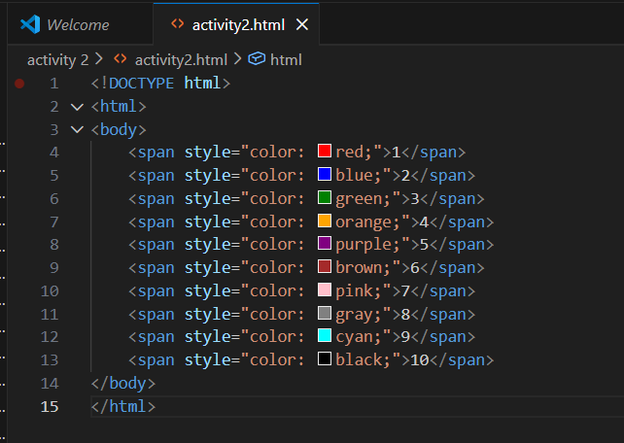

Exercise 3: Print your name in a Tahoma font.
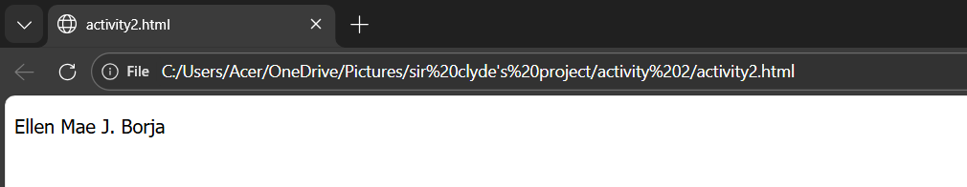
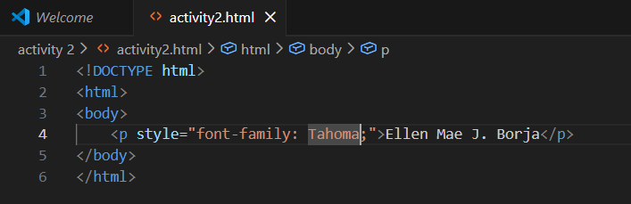

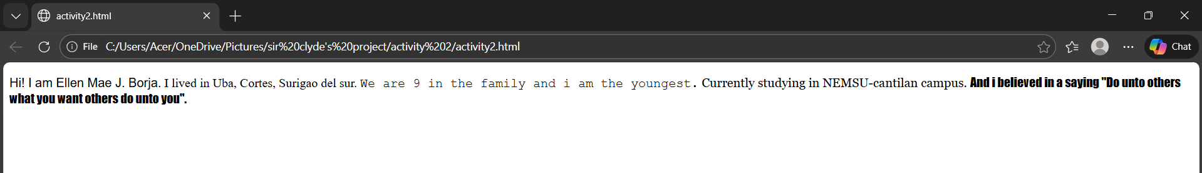
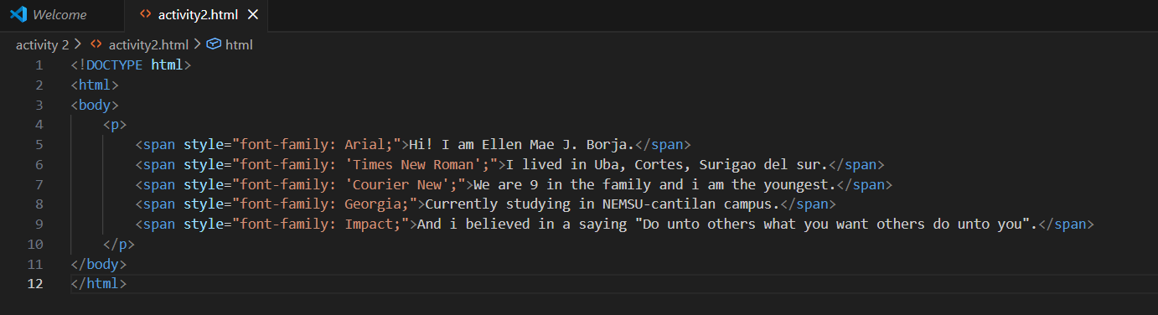
Exercise 4: Print a paragraph with 4-5 sentences. Each sentence should be a different font.

Exercise 5: Print a paragraph that is a description of a book, include the title of the book as well as its author. Names and titles should be underlined, adjective should be italicized and bolded.

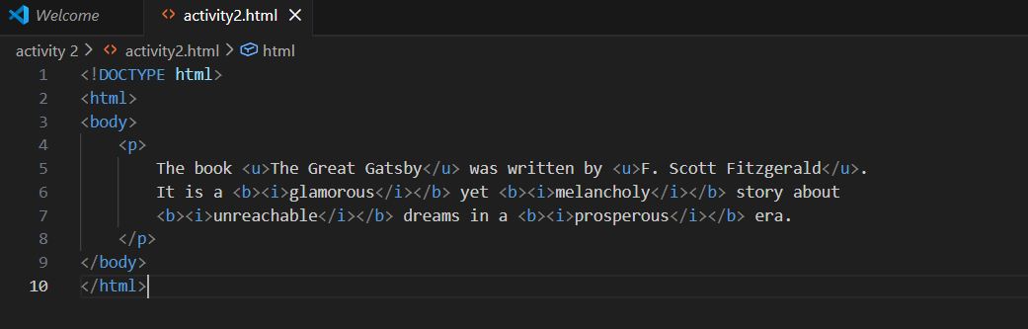

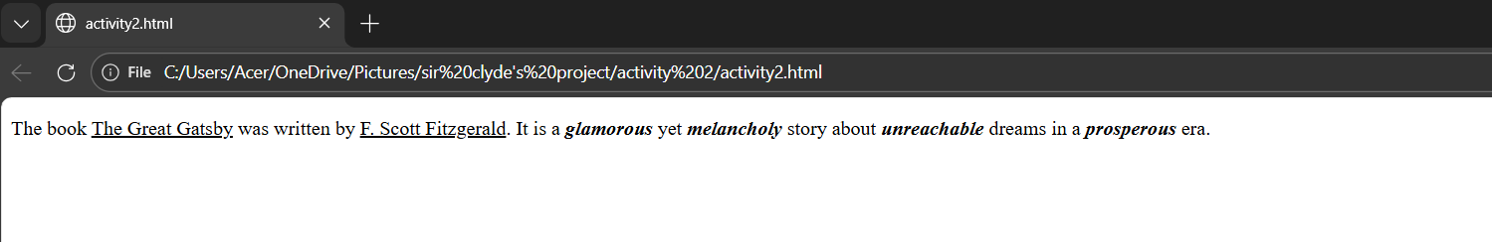

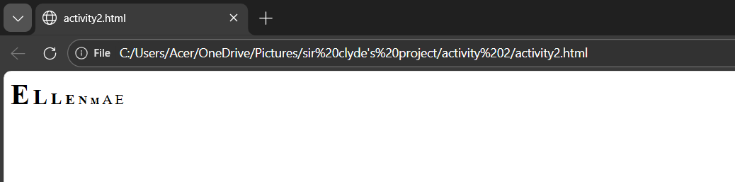
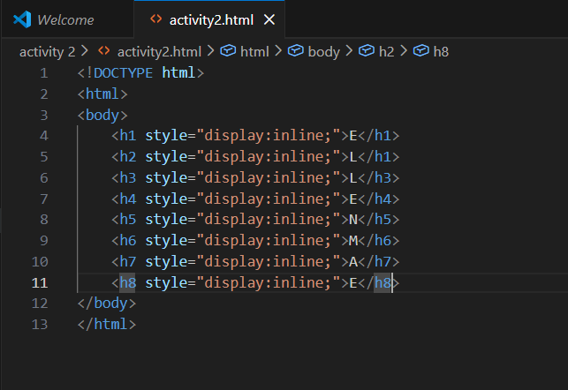
Exercise 6: Print your name to the screen with every letter being a different heading size.

